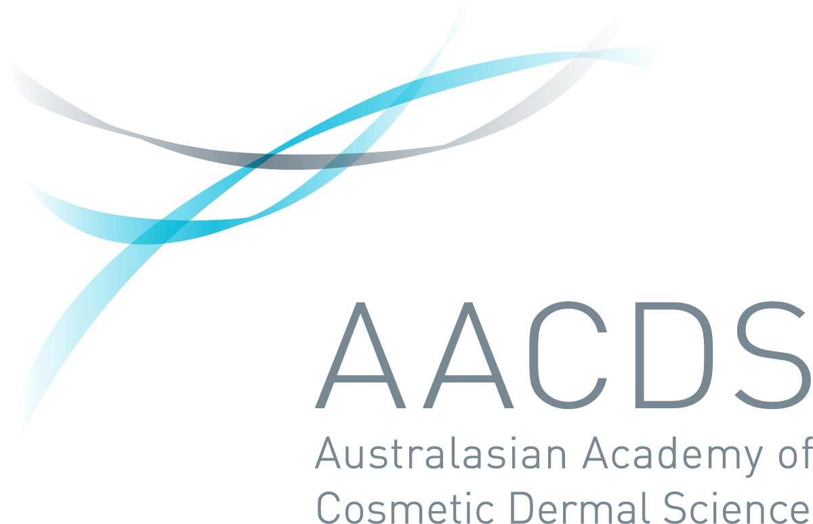
APPLICATION FORM
PROFESSIONAL CERTIFICATE COURSES

Please complete this form and email to:
enquiries@aacds.edu.au

Please ensure that you complete ALL the fields on this form. Non-completed forms could result in a delay in the enrolment process.

- PERSONAL DETAILS
Title | Surname |  | Given Name(s)
Mobile Number |  | Home: |  |  | Work:
 |  | ( ) |  |  | ( )

Email Address
 |  |  | Best contact method: Mobile / Home / Work
Date of Birth |  |  | Gender
 |  |  | M F Other

Residential Address
Suburb: |  |  | State: | Post Code:

Postal Address
Suburb: |  |  | State: | Post Code:

- COURSE - Please tick which course you wish to study
 | Course Title | Tuition Fees (GST Incl)
 | Professional Certificate in Clinical Laser Procedures (Laser Hair Reduction) with Supervised Hours | $4,125
 | Professional Certificate in Clinical Laser Procedures (Laser Tattoo Removal) without Supervised Hours | $1,125
 | Professional Certificate in Integrated Health and Dermatology | $2,112
 | Laser Bridging Course for AACDS Graduates | $3,025
 | Laser Safety Officers Certificate FAST TRACK | $370
 | CDNLBT02 Analyse Laser and Light-Based Therapies used in Cosmetic Medicine/ Laser Safety Officers Certificate | $880
 | Analyse the principles of laser tattoo removal | $275
 | HLTINF005 Maintain infection prevention for skin penetration treatments | $440
 | Professional Certificate in Dermatology and Dermatoscopy for Aesthetic Practice | $850
 | Professional Certificate in the Management and Promotion of the Cosmetic Practice | $850
- *Refer to www.aacds.com.au for course structure

- PREFERRED COMMENCEMENT DATES – When do you wish to commence your studies?
Preferred month:

- USI - (ONLY APPLICABLE FOR HLTINF005 Maintain infection prevention for skin penetration treatments and
CDNLBT02 Analyse Laser and Light-Based Therapies used in Cosmetic Medicine/ Laser Safety Officer Certificate)
USI

- IDENTIFICATION ATTACHED (Please attach any 1 of the following)
 | Driver’s License |  | Passport |  | Birth Certificate |  | Australian Citizenship Certificate

- PREFERRED PAYMENT METHOD
 | General Fees |  | Payment Plan |  | Study Loans |  | Employer
*Payment plan – only applicable for courses above $1000.00
*Study loans – only applicable for courses above $2001.00
*Employer – please provide:
- Employer name-
- Employer contact number -
- Employer email-
- Business name -
- Business address-

How did you hear about us / the course?
 | Website |  | Google Search |  | Social Media |  | Expo / Event (please specify)
 | Radio |  | Word of Mouth |  | Newspaper |  | Email Advertisement
 | Past Student |  | Education Agent |  | Magazine |  | Industry Association

- DO YOU NEED FURTHER INFORMATION or ASSISTANCE?
Student Success Officer - (08) 9328 6760 enquiries@aacds.edu.au

Privacy Statement
The Australasian Academy of Cosmetic Dermal Science (AACDS) is a trading name of the Niche Education Group Pty Ltd. The information collected in this form is required to facilitate your enrolment and will be handled and stored in line with the Niche Education Group Pty Ltd’s Student Personal Information Policy. The Group reserves the right to verify any of the details you have provided on this form in order to assess your application.

AACDS will contact you with the link of a pre-enrolment presentation followed by a quick pre-enrolment phone call once your application has been reviewed.

